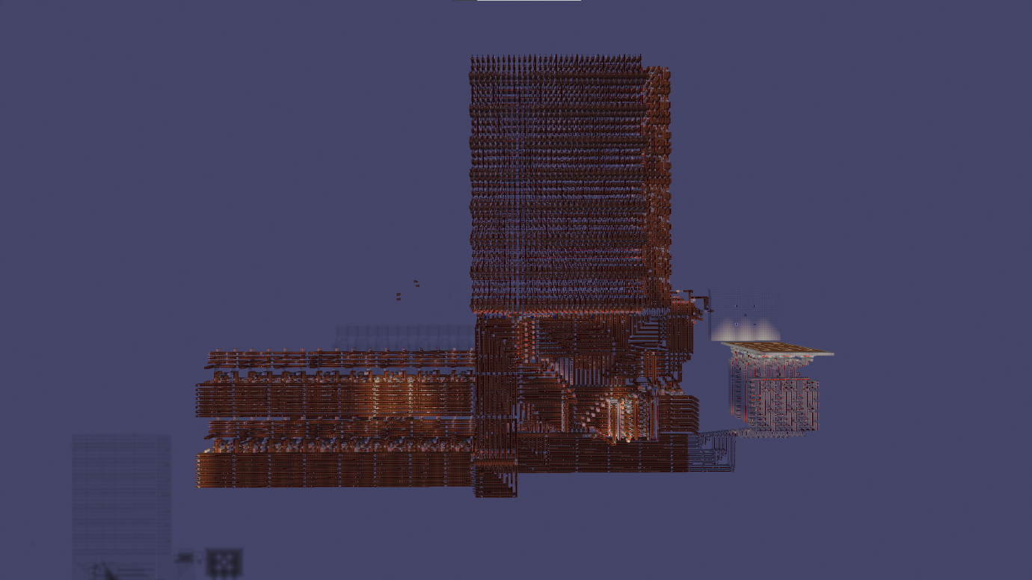I built my first computer in Minecraft from basic logic gates, latches, and a clock

Here is an explanation of the most basic Minecraft Redstone components, partly by AI:

**Redstone Wire**: redstone wires are used to transmit power from one place to another. They can transmit a signal only 15 blocks, after which they need a repeater to boost the signal back up to full strength. When crossing each other, redstone wires must be kept isolated so they don’t interfere with each other.

**Redstone Torch**: Redstone Torches: Redstone torches provide power to redstone wires. They grant power with a signal strength of 15 to any adjacent redstone dust, or to the block above them, from which a redstone dust signal can then be taken. Torches will also activate any redstone components above or beside them, such as lamps. Redstone torches can be useful in computing because, while their default state is ON, they can be turned OFF by sending a signal to them through redstone wires, acting as a NOT gate.

**Redstone Repeater**: A redstone repeater is a block that produces a full-strength output signal from its front when its back is powered, with four configurable delay settings. It is used to boost the signal strength of redstone wires after every 15 blocks. It can also be locked into a power state by its side being directly powered by another repeater or a comparator. This is particularly useful in computing as it can be used to create latches.

**Redstone Comparator:** They have three ports, with two being for input and the third for output. A redstone comparator can produce an output signal from its front by reading chests and barrels, or repeat a signal without changing its strength. A comparator has two "modes": "compare mode" and "subtract mode". The default mode is "compare" mode, which means that it will compare the signal it receives from the side to the signal it receives from behind. If the signal from the side is stronger than the one from behind, it won't give off a signal. If the signal from the side is weaker than the one from behind, the comparator will give off a signal equal to the one it receives from behind. On "subtract" mode, the comparator will produce a signal equal to the signal it receives from behind minus the signal it receives from the side.



These can be used to make logic gates, latches, clocks and other circuits:



Mattbatwings on YouTube has more in-depth explanations about this:

<https://www.youtube.com/playlist?list=PL5LiOvrbVo8keeEWRZVaHfprU4zQTCsV4>

**The computer:**

|  |  |
| --- | --- |
| **Computer Specifications** | |
| ROM (Instruction Memory) | 64 33-word registers. |
| RAM | 2, 8-bit, 7-register modules. |
| ALU Operations (8-bit) | AND, OR, XOR, NOT, ADD, SUBTRACT, BRANCH IF ONE |
| Magnitude Comparator (MGC) (8-bit) | Equality Check, Less-Than Check, Greater-Than Check |
| Clock Speed | 36 Second Clock Cycle (0.027 Hz) |
| Program Counter | Supports Branching (Conditional and Unconditional) |
| Display (7-Segment) | Displays the value of the 8-bit display register after converting it to base 10 |
| Cache | stores the last ALU and/or MGC calculation to be released into the RAM when necessary |

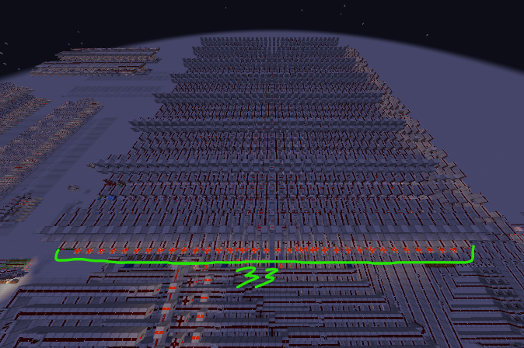

|  |  |  |  |  |  |
| --- | --- | --- | --- | --- | --- |
| **Purpose of Each ROM Bit** (Note that all register addresses and operations start from ONE not zero) | | | | | |
| 0 CACHE | 00000 RAM 2 | 000000 RAM 1 | 00000 ALU/MGC | 00000000 LINE 2 | 00000000 LINE 1 |
| If on, passes the last ALU operation to the specified RAM address  (left bit does nothing, yet) | Three right bits: determines the register to read / write from R1-7  To load an immediate value to RAM, put it through the ALU on ADD, XOR or OR mode, make sure only one main line has data on it. | Three right bits: determines the register to read / write from R1-7  To load an immediate value to RAM, put it through the ALU on ADD, XOR or OR mode, make sure only one main line has data on it. | 00001 Compares the magnitude of L1 and L2 and writes it to RAM. If L1>L2 it writes to bit 6, if L1=L2 it writes to bit 7, if L1<L2 it writes to bit 8. (Writes an on state, that is) | This can bus a value to the ALU and MGC. Set this line to a number and then add zero to it to write to RAM | This can bus a value to the ALU and MGC. Set this line to a number and then add zero to it to write to RAM |
|  | Bit 4: off for read, on for write | Bit 4: off for read, on for write | 00010 Bitwise AND,  (Refer to the example below this table)  00011 Bitwise OR, 00100 Bitwise XOR, 00101 NOT, 00110 ADD L1 and L2,  00111 Subtract L2 from L1, 01000 Conditional Branch: Changes the current instruction to the value of L1 IF L2=1 | If the ALU operation is set to branch-if-one and this line is equal to one, the program counter will branch to the instruction address equal to the value of line 1. | If the ALU operation is set to branch-if-one and line 2 is equal to one, the program counter will branch to the instruction address equal to the value of this line. |
|  | Bit 5: Off for write to line 2, On for write to line 1 | Bit 5: Off for write to line 2, On for write to line 1 |  |  |  |
|  |  | Bit 6: By default, the ALU and MGC write to RAM 1, turn this bit on to write to ram 2 |  |  |  |
|  |  |  |  |  |  |
|  |  |  |  |  |  |
|  |  |  |  |  |  |

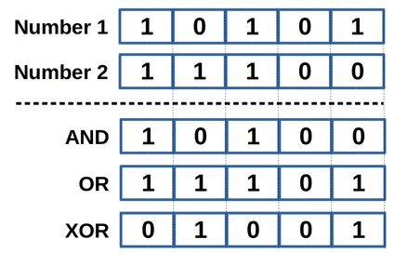

Notes: Instead of implementing my own 8-bit logic operators and binary adder to create the ALU, I decided to use an ALU that I found online primarily to save space. I also used a magnitude comparator design from the internet. Additionally, I use a standard seven-segment display that decodes 4 bits into each base 10 number 1-9 and then displays the appropriate segments. The 8-bits of the display register (R7 of RAM 2) are fed through a combinational binary-to-BCD converter that uses the Double Dabble Algorithm.

There is a potential bug that the writing to the same RAM address two times in a row will not clear the current stored bits the second time, however I am not sure if this is the case, and there shouldn’t be a time where it is necessary to use this feature anyway.

|  |  |  |  |  |  |  |  |  |  |  |
| --- | --- | --- | --- | --- | --- | --- | --- | --- | --- | --- |
| **0** | **0** | **0** | **000** | **0** | **0** | **0** | **000** | **00000** | **0000**  **0000** | **0000**  **0000** |
| Turn on to pass the cache through to RAM | Off means ram 2 writes to line 2, on means ram 2 writes to line 1 | Off for ram 2 to read, on for ram 2 to write | Addresses 1-7 for ram 2 | Off for ALU and MGC and Cache to ram 1, on for ALU and MGC and Cache to ram 2 | Off for ram 1 to write to line 2, on for ram 1 to write to line 1 | Off for ram 1 to read, on for ram 1 to write | Addresses 1-7 for ram 1 | 00001 MGC  00010 AND  00011 OR  00100 XOR  00101 NOT  00110 ADD  00111 Subtract  01000 Branch  // Has support for more operations in future | Bus | Bus |

(RAM2-7 Is the display register)

**Example Program: Fibonacci Sequence**

Psuedocode:

1. Load 00000001 to RAM1-1
2. Load RAM1-1 to RAM2-7 //(copy)
3. Add RAM1-1 and RAM2-7
4. Load Cache to RAM2-7

// Now RAM1-1 is 1, RAM2-7 is 2

1. Add RAM1-1 and RAM2-7
2. Load Cache to RAM1-2
3. Load RAM2-7 to RAM1-1
4. Load RAM1-2 to RAM2-7

// Now RAM1-1 is 2, RAM2-7 is 3

1. Branch If One 00000001 00000101

// This should increment the Fibonacci Sequence

Machine Code:

1. 0|00000|001001|00110|00000000|00000001 // **R1-1** is 1, **R1-2** is 0, **R2-7** is 0, **Cache** is 1
2. 0|01111|100001|00110|00000000|00000000 // **R1-1** is 1, **R1-2** is 0, **R2-7** is 1, **Cache** is 1
3. 0|10111|000001|00110|00000000|00000000 // **R1-1** is 1, **R1-2** is 0, **R2-7** is 1, **Cache** is 2
4. 1|01111|100000|00000|00000000|00000000 // **R1-1** is 1, **R1-2** is 0, **R2-7** is 2, **Cache** is 2
5. 0|10111|000001|00110|00000000|00000000 // **R1-1** is 1, **R1-2** is 0, **R2-7** is 2, **Cache** is 3
6. 1|00000|001010|00000|00000000|00000000 // **R1-1** is 1, **R1-2** is 3, **R2-7** is 2, **Cache** is 3
7. 0|00111|001001|00110|00000000|00000000 // **R1-1** is 2, **R1-2** is 3, **R2-7** is 2, **Cache** is 2
8. 0|01111|100010|00110|00000000|00000000 // **R1-1** is 2, **R1-2** is 3, **R2-7** is 3, **Cache** is 3
9. 0|00000|000000|01000|00000001|00000101 // **R1-1** is 2, **R1-2** is 3, **R2-7** is 3, **Cache** is 3

Pictures:

* 2x RAM, Control lines can be seen on the right of the modules:

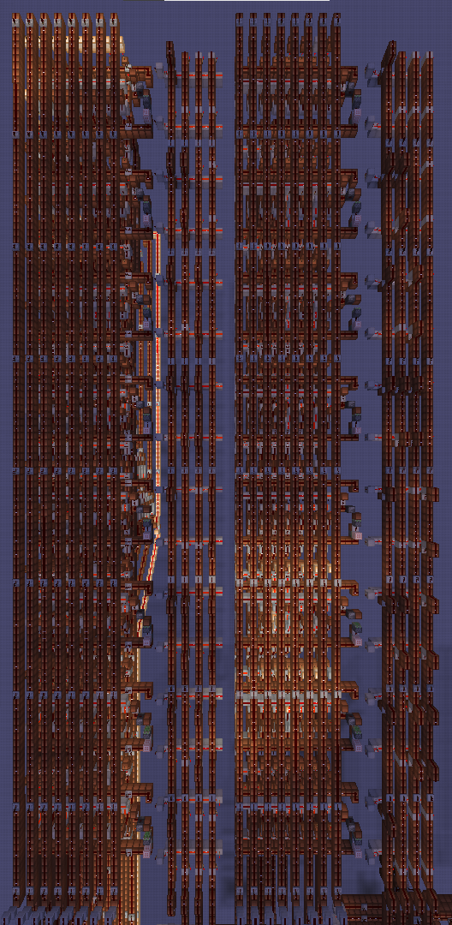

* ROM, 64 33-word registers:

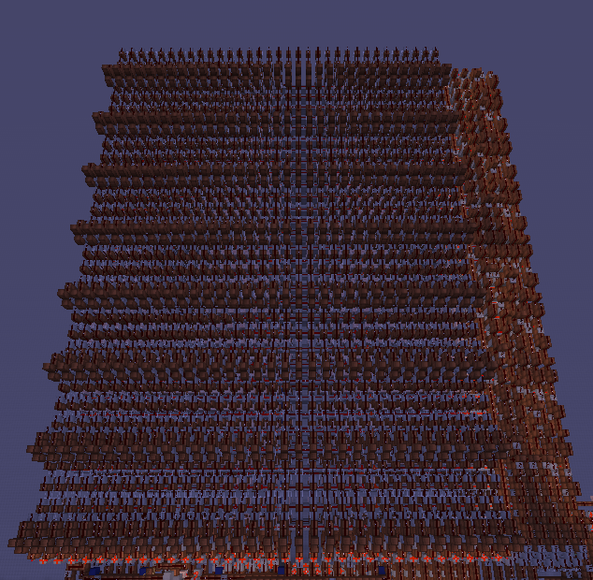

(Programmable through placement of Redstone torches each representing 1 bit):

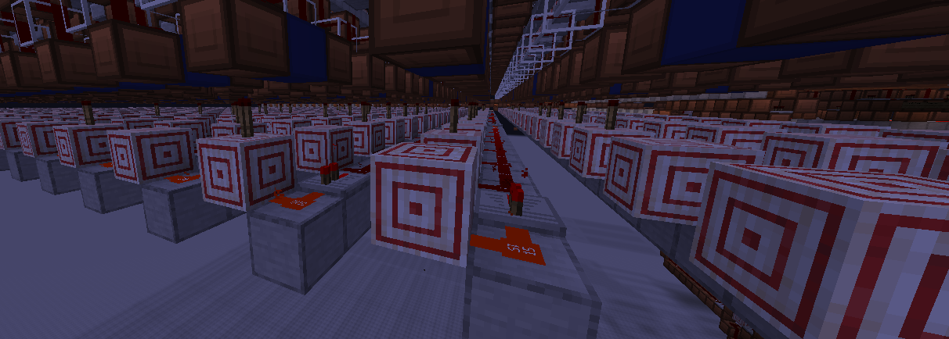

Double Dabble algorithm implementation that converts the 8-bit value of the display register into BCD (binary-coded decimal):

Note that these decoder-based modules are not my design, the module that I made for it was not decoder based and looked like this:

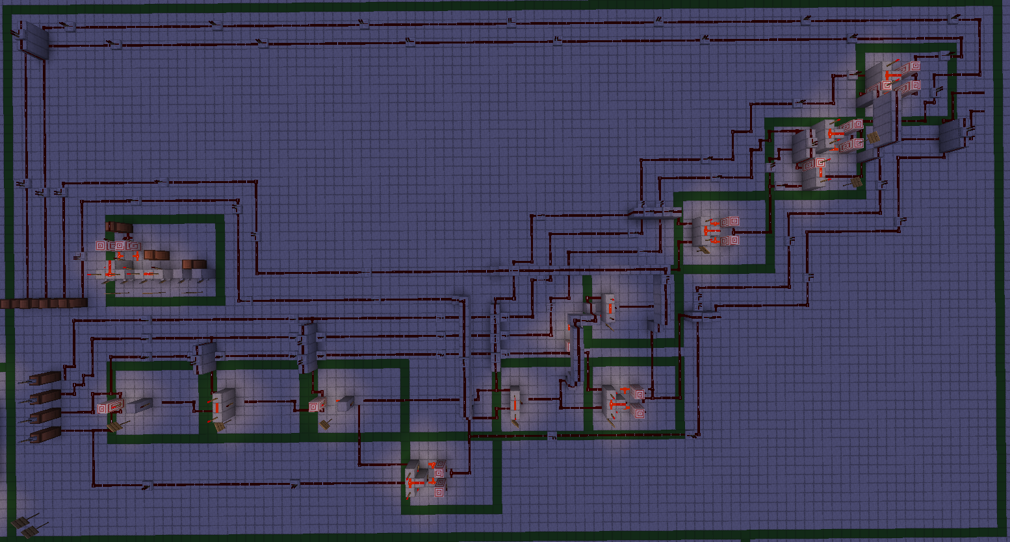

(Which represents this):

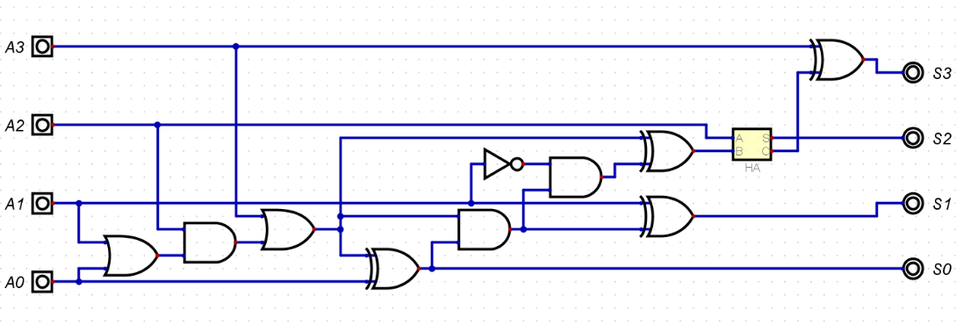

The binary-coded decimals are then decoded into their respective seven segments

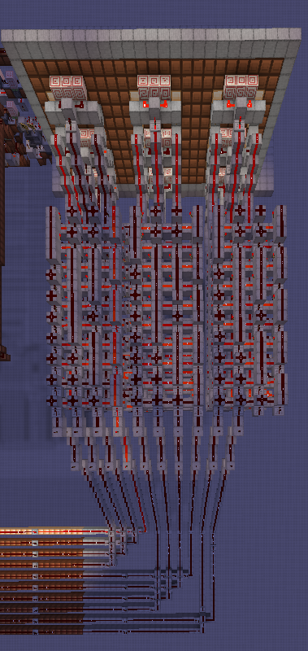

Which are then output on the seven-segment display:

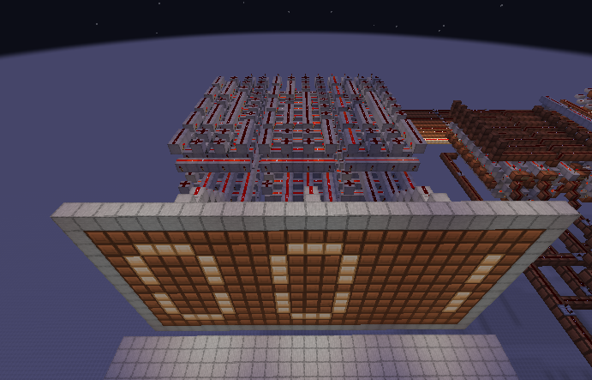

This is the program counter; I took the design from the internet:

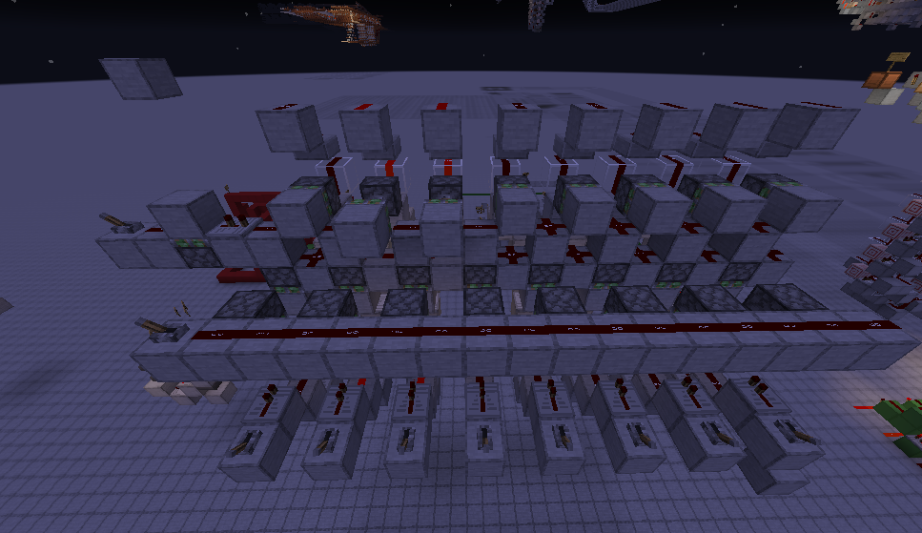

And then expanded upon it to connect it to a clock and to connect it to a conditional branching line

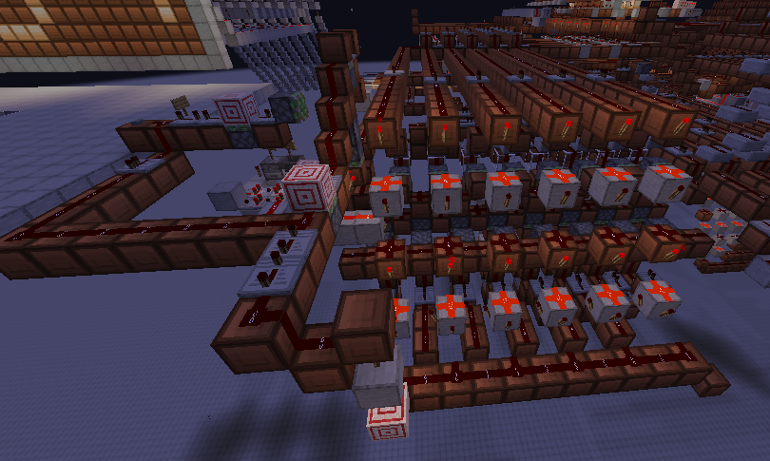

This is my 8-bit binary adder design, along with my XOR gate that I could have combined into one module to create an ALU (AND and NOT gates would also be necessary):

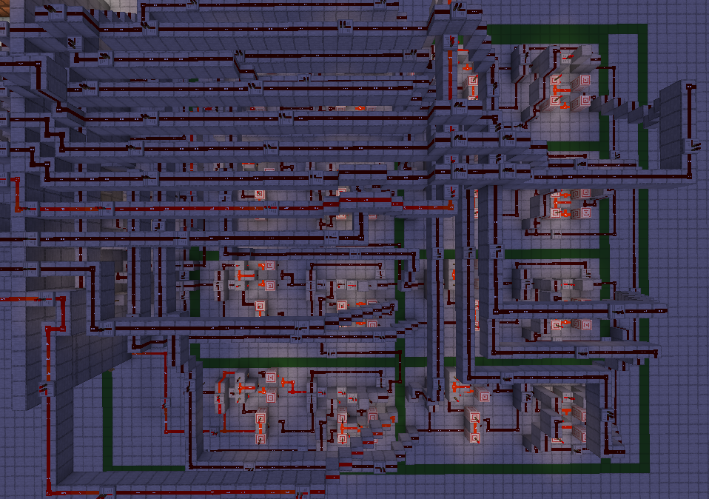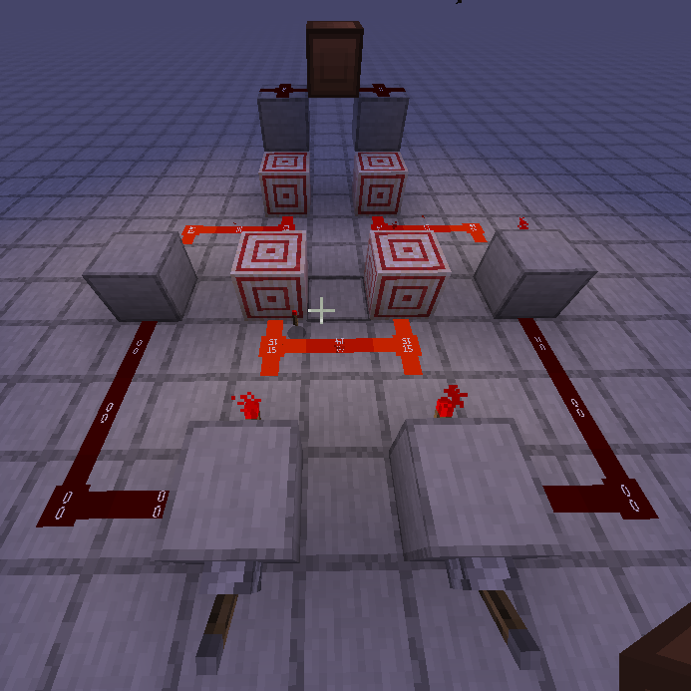

However this design online was more compact, and so for simplicity I went with this:

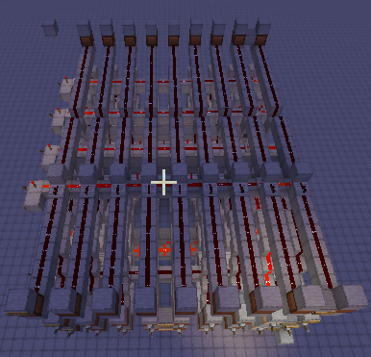

This is the cache that stores the last ALU operation:

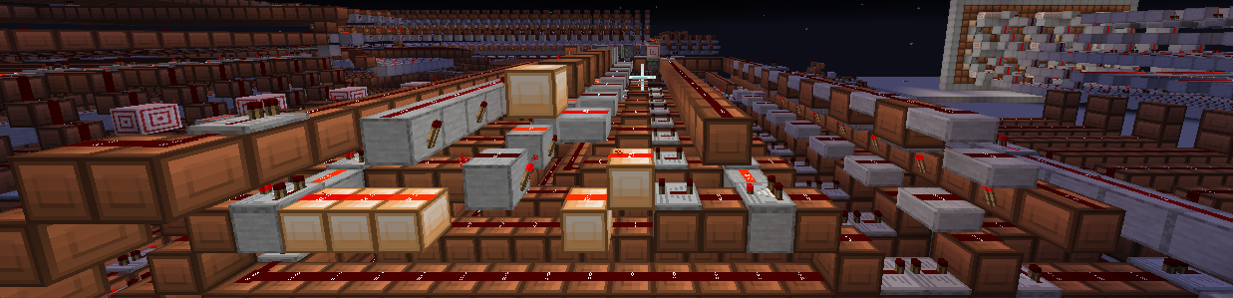

While the magnitude of 2 numbers could already be compared, I decided to add this module I found online to the computer to make it doable in just one instruction:

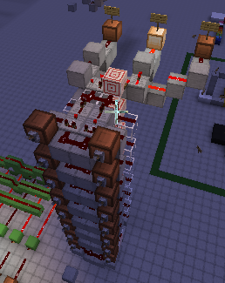

There were also a lot of demultiplexers used, mainly for writing to the 2 ram modules and for reading ram addresses to the 2 control lines:

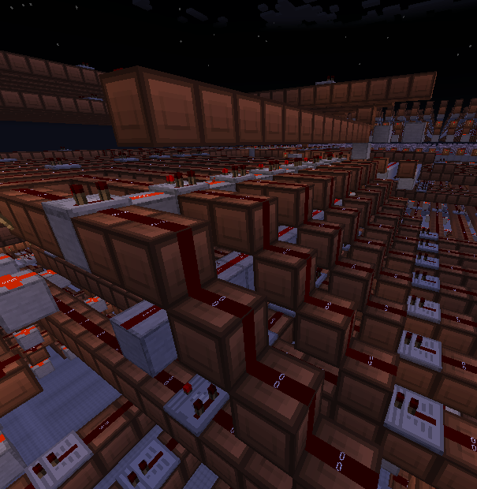

Decoders were also used for the ROM and RAM: 

Additionally, there were many more, less notable circuits used throughout the build, such as monostable circuits:

